Selenium Exceptions Explained | Tamil | Why is it Happening? | Finding the reason behind Exceptions

Exceptions are inevitable in any program. A sudden an unexpected behaviour is known as Exception. In this video, we are going to analyze the most important and frequently occurring exceptions in Selenium.
Selenium Exceptions reference: https://bit.ly/2spiZbV
List of Important Exceptions in Selenium: ---------------------------------------------------------------
WebDriverException
03:15 NoSuchElementException
06:37 StaleElementReferenceException
10:33 UnhandledAlertException
12:15 InvalidElementStateException
15:42 ElementNotVisibleException
18:40 NoSuchFrameException
20:53 NoSuchSessionException
22:08 UnreachableBrowserException
25:13 NoSuchWindowException
26:12 ElementNotInteractableException
28:16 TimeoutException
29:11 SessionNotCreatedException
30:07 JavascriptException
In program, we have given set of code to do particular task, due to sudden unexpected behaviour the program stop, so sudden unexpected behaviour is known as Exception..
If we know the exception, its easy to debug and correct the particular line in the code
Above all are selenium exception, we have java exception also like arithmetic exception[diving 0 by any number], arrayoutofbound[retrieving/reading array which is not present] exception etc
WebDriverException -> its a parent/root exception in selenium..under this only, below all exception present
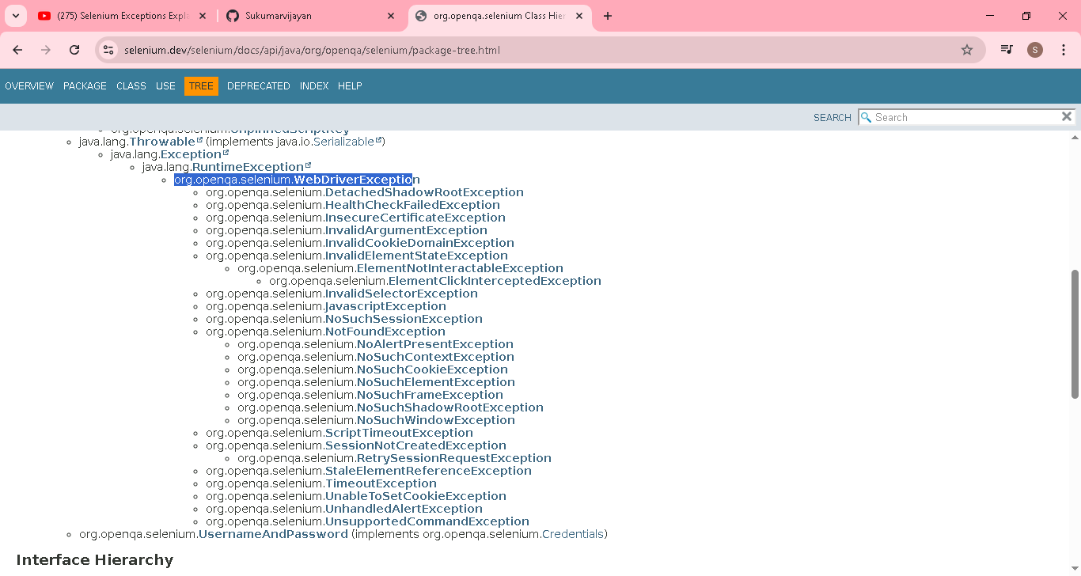
03:15 NoSuchElementException ->element not present in application, in that time its will thow this exception
Note: selenium itself present under java only..below pic show where the NoSuchElementException present
Parent -> WebDriverException & then NotFoundException & then NoSuchElementException
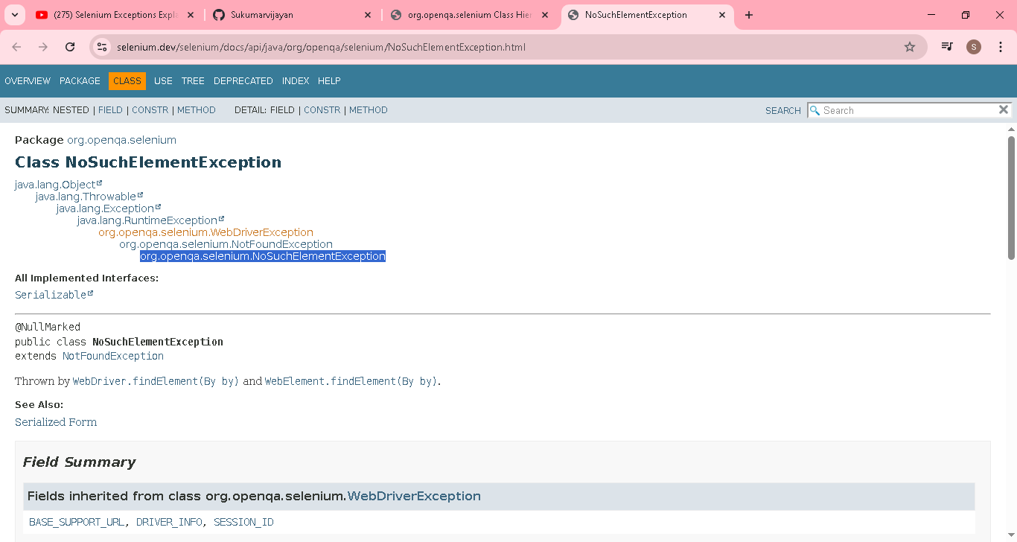

Thrown by WebDriver.findElement(By by) and WebElement.findElement(By by).
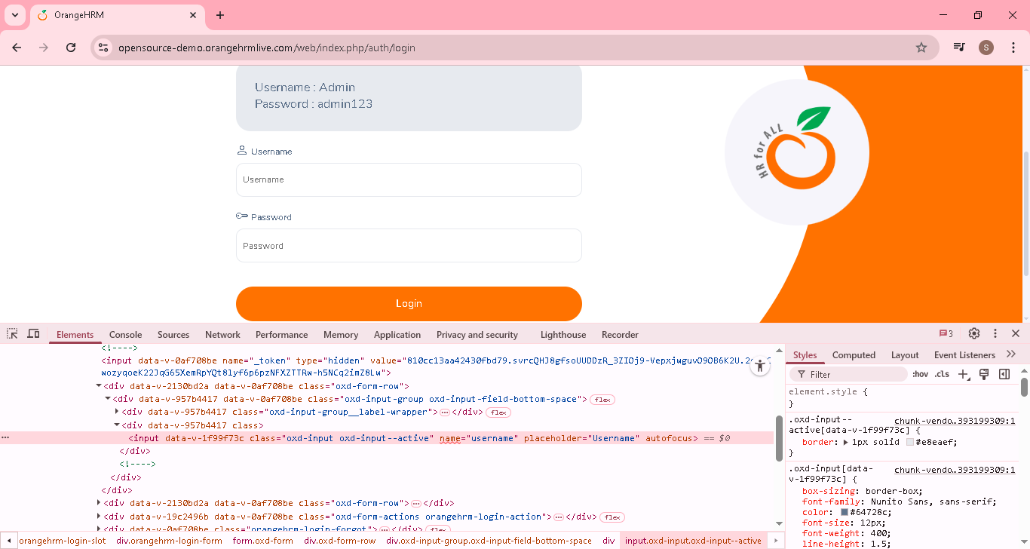
Name is username, am using username123
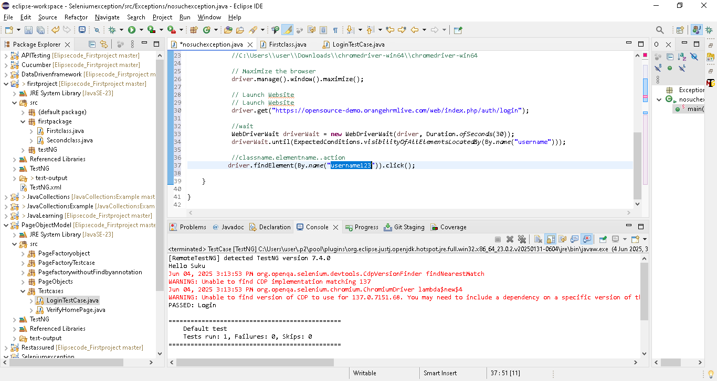

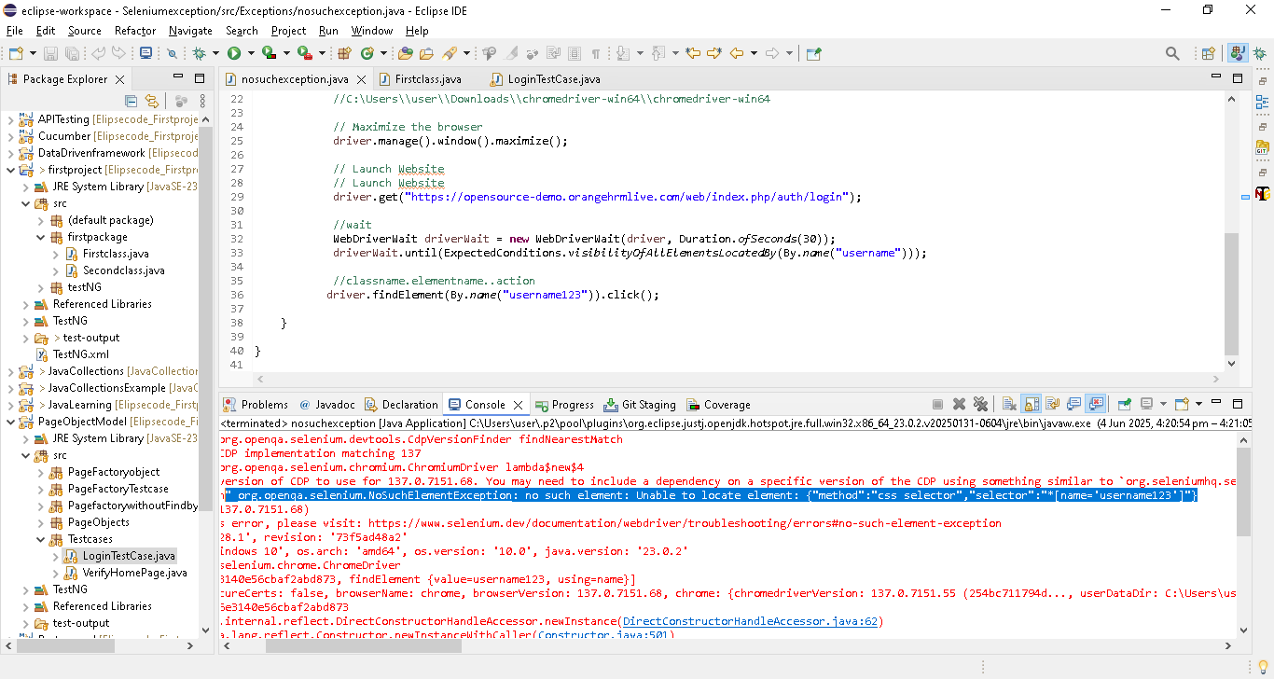

Below pic error no is 36[usually last line]..so we directly go to line 36 & correct the issue
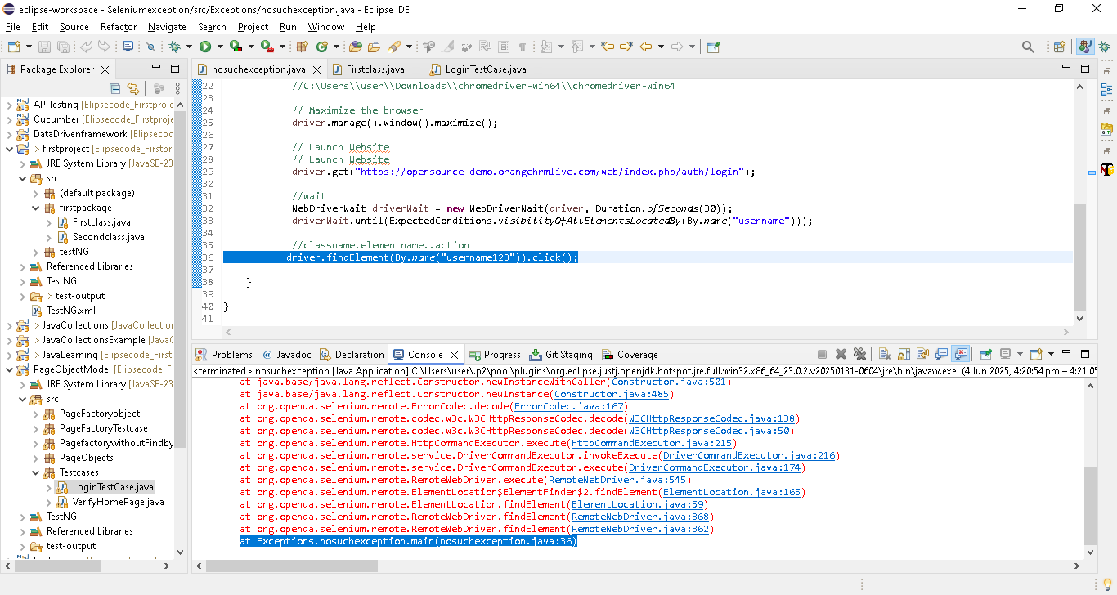

06:37 StaleElementReferenceException
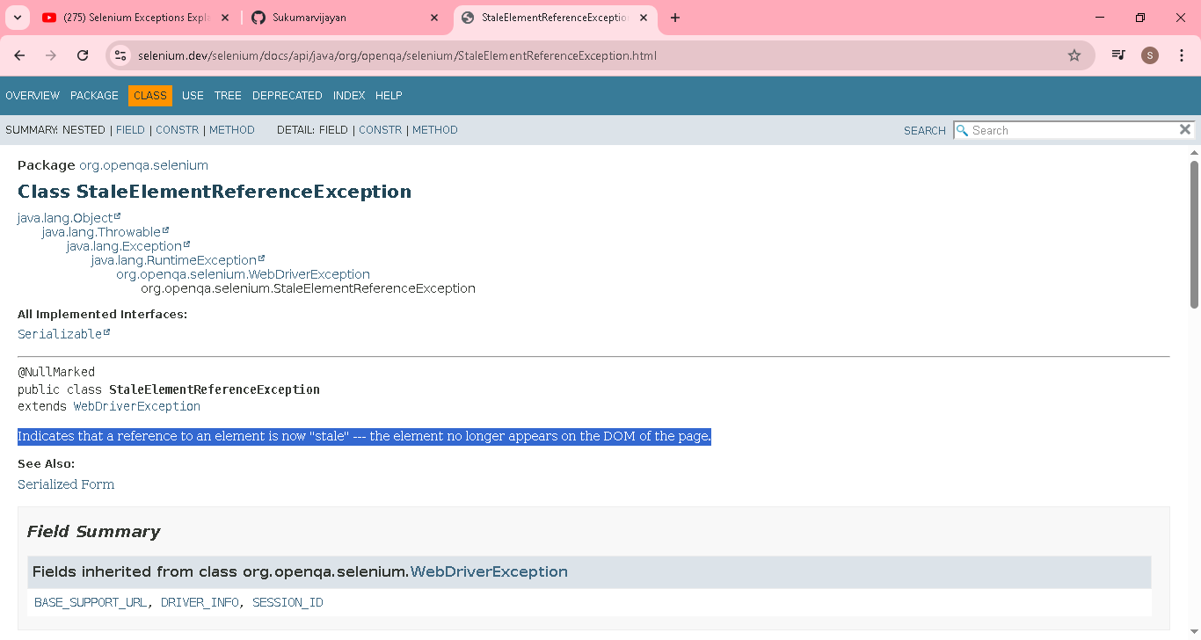
Stored the element property, then the page is refreshed or redirected, then if we interact with element it will throw StaleElementReferenceException , even though element property is same..
To avoid , again store the element property after refresh & do the operation

Eg..google search webedit
WebElement element = driver.findElement(By.name("q"));
element.sendKeys("Covai"+ Keys.ENTER);

element.clear();

before search also, webedit property is “q”

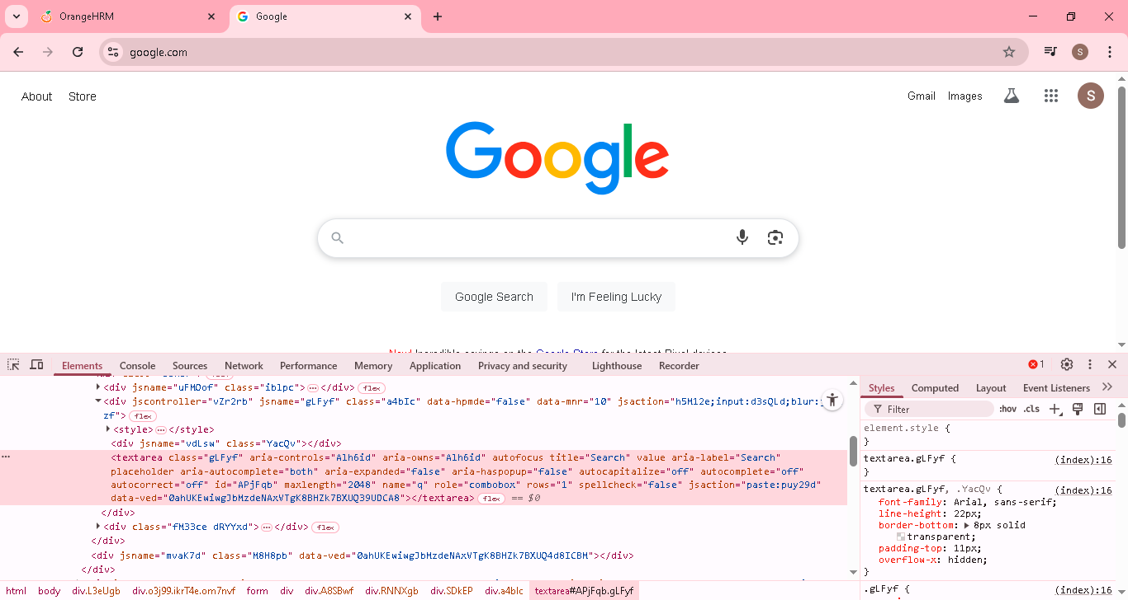
After search result also, webedit property is “q”
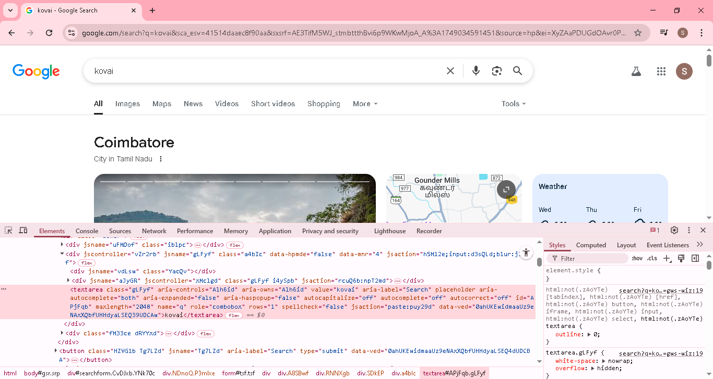

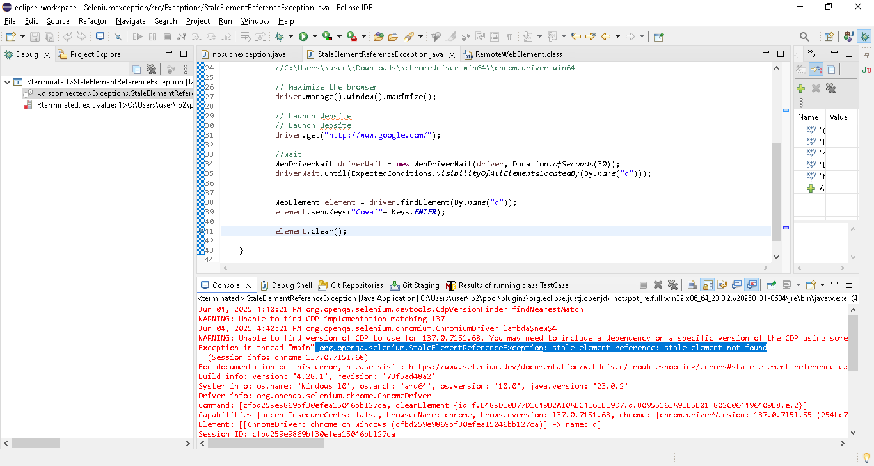

To avoid this error
WebElement element = driver.findElement(By.name("q"));
element.sendKeys("Covai"+ Keys.ENTER);

//again store the element property & do the opartion
WebElement element = driver.findElement(By.name("q"));

element.clear();

Below pic error no is 41[usually last line]..so we directly go to line 41 & correct the issue
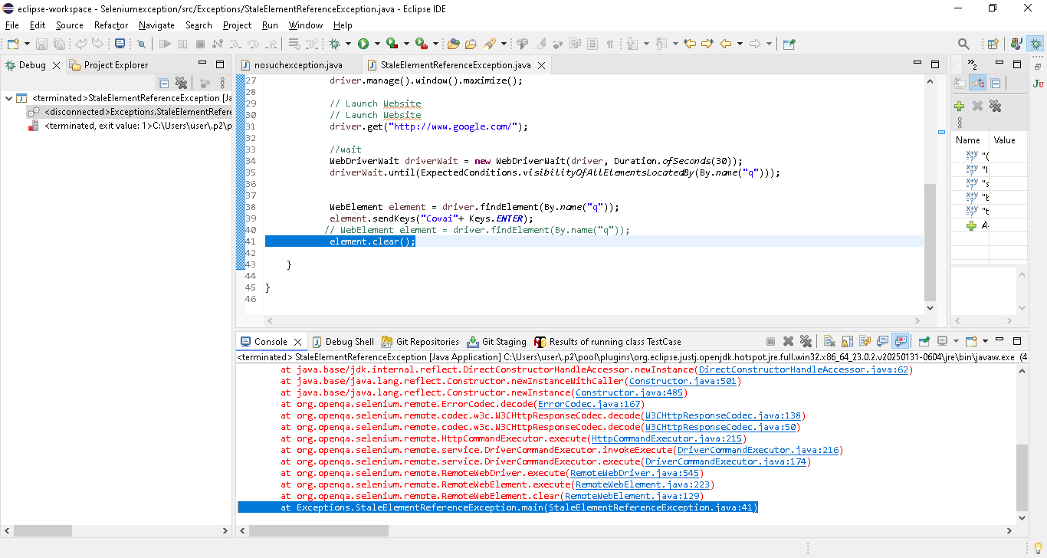

10:33 UnhandledAlertException ->if there is an alert in a webpage, but u didnot handle it & trying to interact with other element in a webpage, in that case it will throw UnhandledAlertException
package Exceptions;
import org.openqa.selenium.By;
import org.openqa.selenium.WebDriver;
import org.openqa.selenium.WebElement;
import org.openqa.selenium.chrome.ChromeDriver;
public class Unhandlealertexception {

public static void main(String[] args) throws InterruptedException {

System.setProperty(
"webdriver.chrome.driver",
"C:\\Users\\user\\Downloads\\chromedriver.exe");

WebDriver driver = new ChromeDriver();
driver.manage().window().maximize();
driver.get("https://leafground.com/alert.xhtml;jsessionid=node0148zoqy7sxgg6bfktprt76nsh1783442.node0");
Thread.sleep(5000);
WebElement element = driver.findElement(By.xpath("//*[@id=\"j_idt88:j_idt91\"]/span[2]"));
element.click();
Thread.sleep(5000);
element.click();

}

}

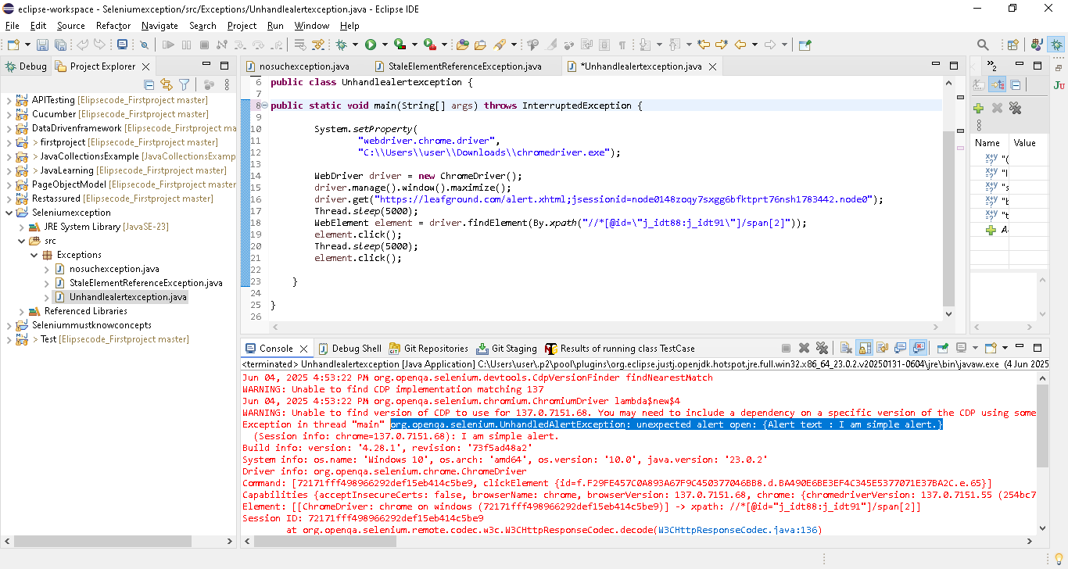
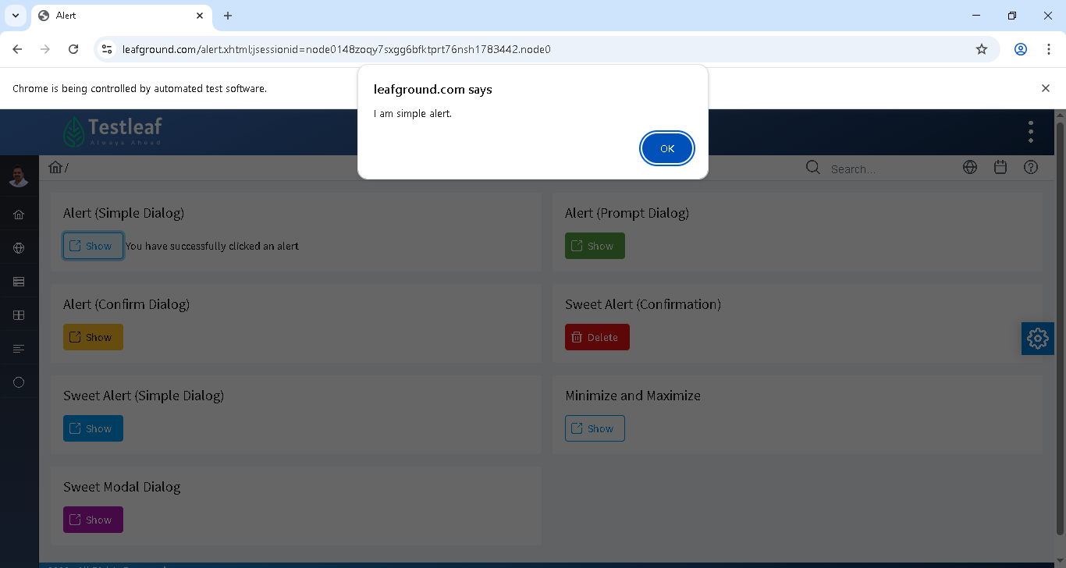

12:15 InvalidElementStateException
In webpage, element is in hidden mode or non editables, if we perform any clear operation on non editables element or hidden, then InvalidElementStateException occur
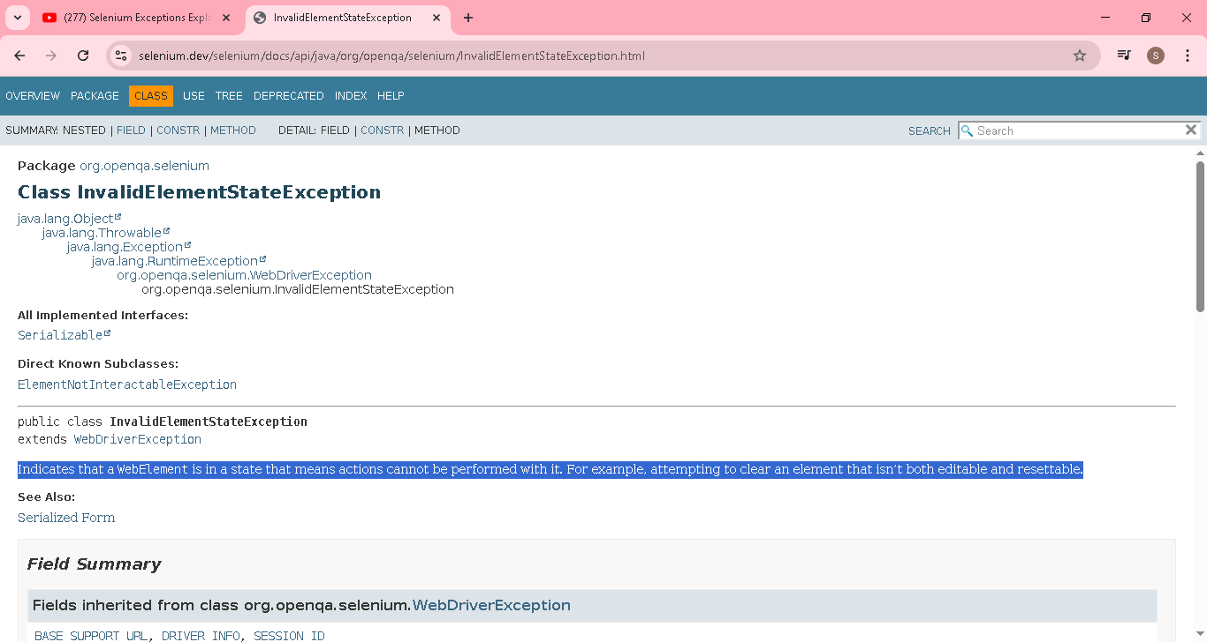

15:42 ElementNotVisibleException
In webpage, element is in hidden mode or non editables, if we perform any Set/click operation on non editables element or hidden, then ElementNotVisibleException occur

ElementNotVisibleException child of InvalidElementStateException..both are similar..only diff
if we perform any Set/click operation on non editables element or hidden, then ElementNotVisibleException occur
if we perform any clear operation on non editables element or hidden, then InvalidElementStateException occur

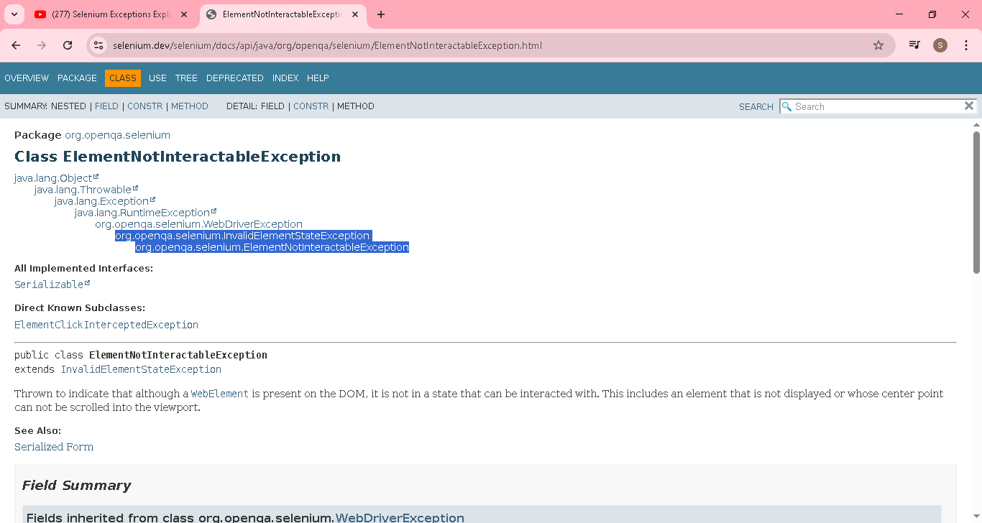

18:40 NoSuchFrameException
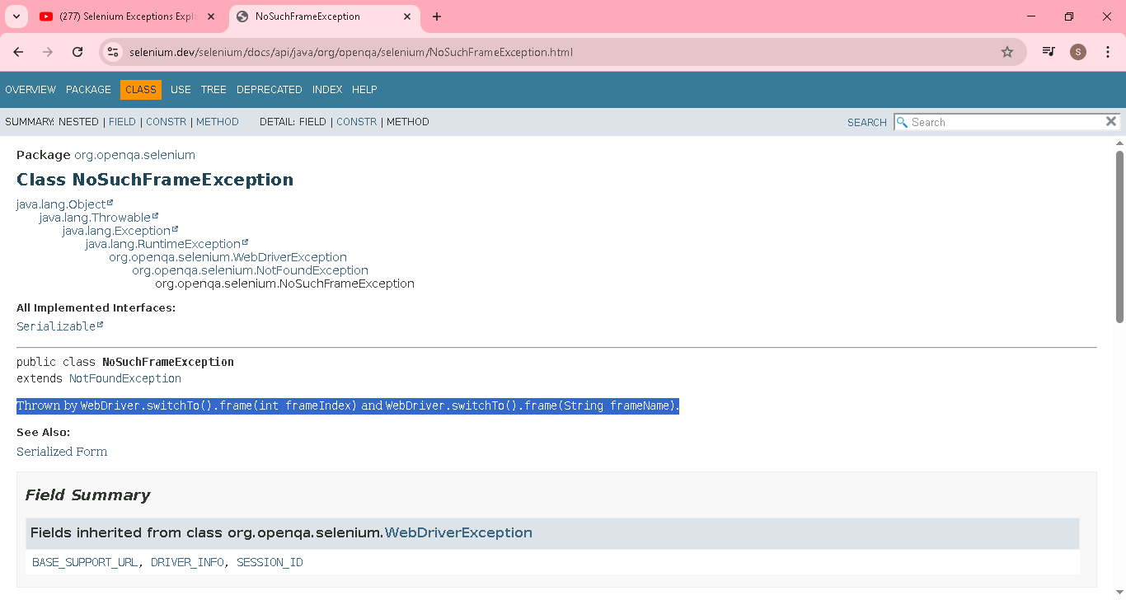
If we try to switch to particular frame [by index or frame name], but if the particular frame not present, then NoSuchFrameException will occur
package Exceptions;
import org.openqa.selenium.By;
import org.openqa.selenium.WebDriver;
import org.openqa.selenium.WebElement;
import org.openqa.selenium.chrome.ChromeDriver;
public class NoSuchFrameException {

public static void main(String[] args) throws InterruptedException {

System.setProperty(
"webdriver.chrome.driver",
"C:\\Users\\user\\Downloads\\chromedriver.exe");

WebDriver driver = new ChromeDriver();
driver.manage().window().maximize();
driver.get("https://leafground.com/frame.xhtml");
driver.switchTo().frame(6);

}

}
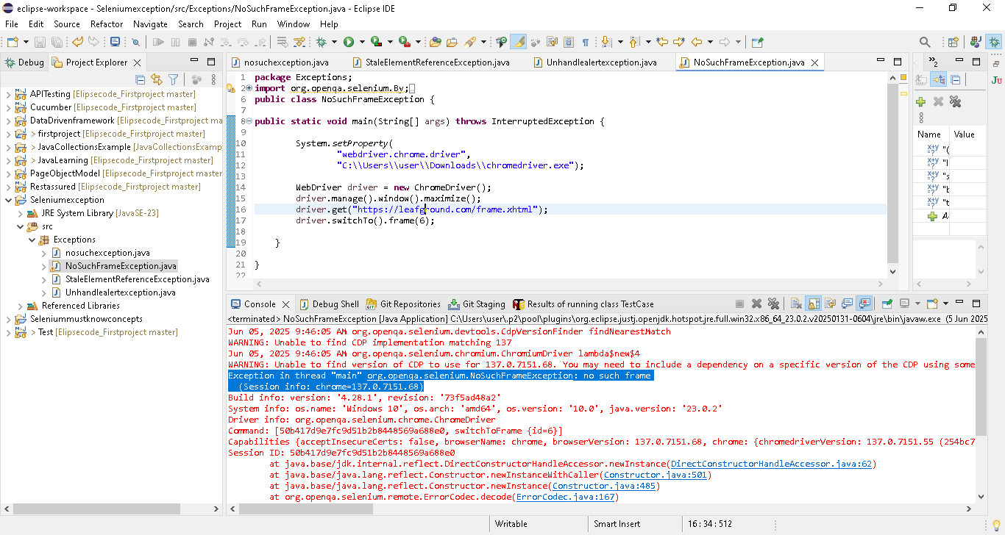

20:53 NoSuchSessionException ->Any action after you quit the browser
package Exceptions;
import java.time.Duration;

import org.openqa.selenium.By;
import org.openqa.selenium.Keys;
import org.openqa.selenium.WebDriver;
import org.openqa.selenium.WebElement;
import org.openqa.selenium.chrome.ChromeDriver;
import org.openqa.selenium.support.ui.ExpectedConditions;
import org.openqa.selenium.support.ui.WebDriverWait;
public class NoSuchSessionException {

public static void main(String[] args) throws InterruptedException {

System.setProperty(
"webdriver.chrome.driver",
"C:\\Users\\user\\Downloads\\chromedriver.exe");

WebDriver driver = new ChromeDriver();
driver.manage().window().maximize();
driver.get("http://www.google.com/");
driver.quit();
WebElement element = driver.findElement(By.name("q"));
element.sendKeys("Covai"+ Keys.ENTER);
}

}

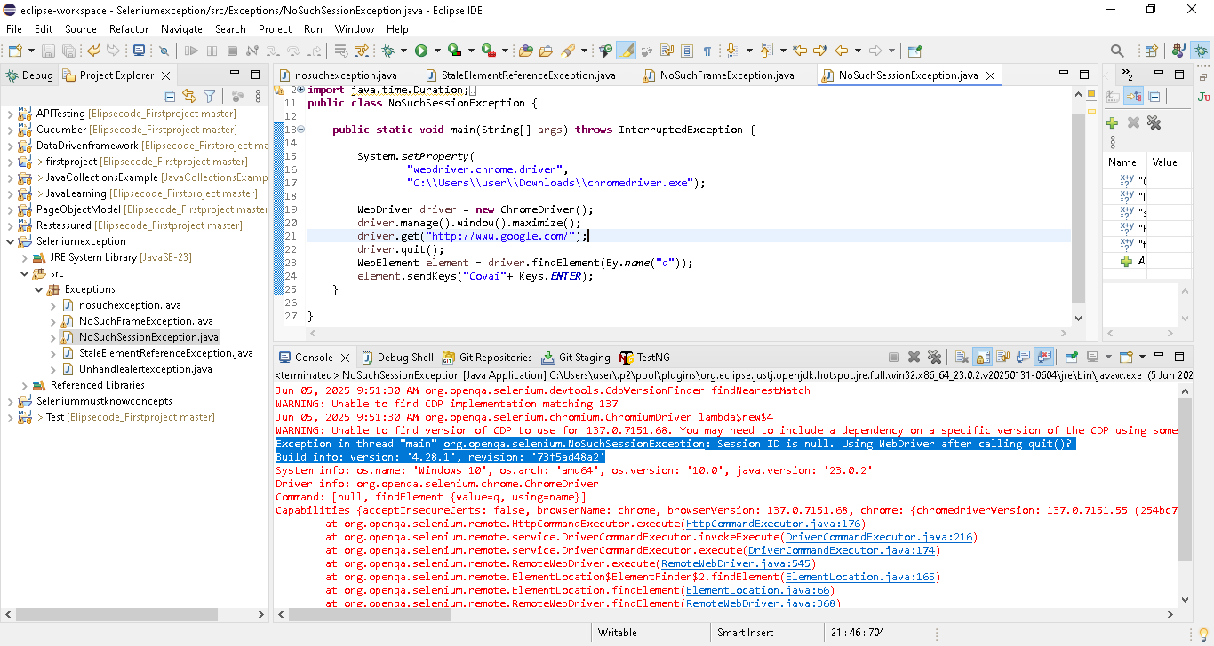

22:08 UnreachableBrowserException
Ur chrome version is 136 & OS: 64 bit windows..but u have downloaded 32 bit chrome driver of chrome version 136..then we will UnreachableBrowserException

25:13 NoSuchWindowException
If we try to switch to particular window [by index or frame name], but if the particular window not present, then NoSuchWindowException will occur
package Exceptions;
import org.openqa.selenium.By;
import org.openqa.selenium.WebDriver;
import org.openqa.selenium.WebElement;
import org.openqa.selenium.chrome.ChromeDriver;
public class NoSuchWindowException {

public static void main(String[] args) throws InterruptedException {

System.setProperty(
"webdriver.chrome.driver",
"C:\\Users\\user\\Downloads\\chromedriver.exe");

WebDriver driver = new ChromeDriver();
driver.manage().window().maximize();
driver.get("https://leafground.com/window.xhtml");
//just provided window name as “Suku”
driver.switchTo().window("Suku");

}

}
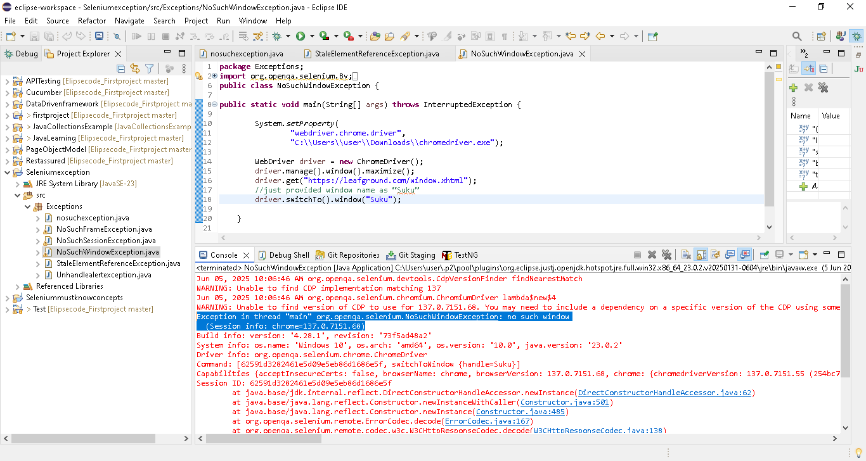

26:12 ElementNotInteractableException
If we are planning to click the particular element, due to slowness, other popup appear in front of that particular element, then other element ill receive the click..in that case ElementNotInteractableException occur

28:16 TimeoutException
driver.get("http://www.google.com/");

if you doing get operation to load the google page, some time due to server issue..page wont load in that default load time..in that TimeoutException will occur
29:11 SessionNotCreatedException -> when browser kill before its run..
driver.get("http://www.google.com/");
//close manually the browser..before its load fully

30:07 JavascriptException
Usually we automate the webpage using selenium with java language..
We can use javascipt language also with selenium to automate webpage..in that case any error in the javascipt language, then it will throw JavascriptException

